COURSE CODE/TITLE: | CPE 010 |  | SECTION: | CPE21S3
DATE PERFORMED: | 9/10/26 |  | DATE SUBMITTED: | 9/15/26
NAME: | Ralf Nicolo B. Abello |  | INSTRUCTOR: | Engr. Jimlord Quejado

ACTIVITY NO. 8.1 | Sorting Algorithms Pt2
1. PROCEDURE OUTPUT
Code + Console Screenshot | 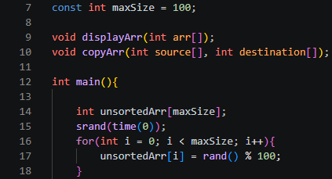  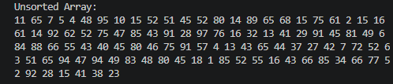
Observations | The array holds 100 values between 0 and 99 generated by rand() % 100, and since srand(time(0)) seeds off the current time, the values come out in a different random order each time I run the program.
Table 8-1. Array of Values for Sort Algorithm Testing

Code + Console Screenshot | 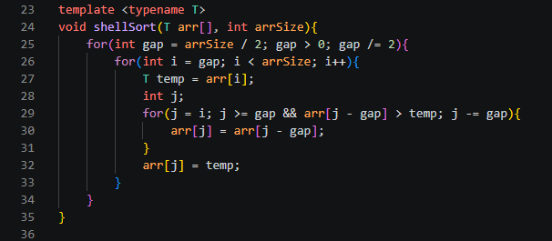  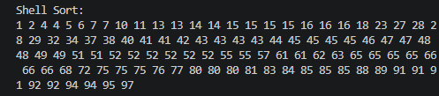
Observations | shellSort starts with a gap of 50 and halves it each pass, so early passes move elements across large distances instead of one step at a time like insertionSort, which cuts down the total number of shifts needed before the final gap-1 pass fully sorts the array.
Table 8-2. Shell Sort Technique

Code + Console Screenshot | 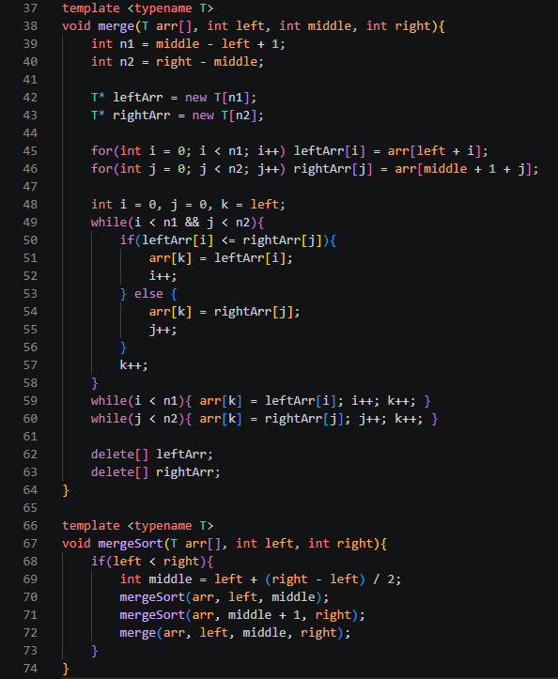  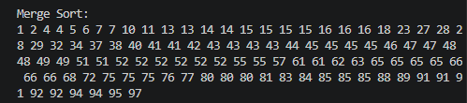
Observations | mergeSort keeps splitting mergeArr in half until each piece has one element, then merge combines those pieces back together in sorted order, so the sorting work actually happens during the merge step rather than the split step.
Table 8-3. Merge Sort Algorithm

Code + Console Screenshot | 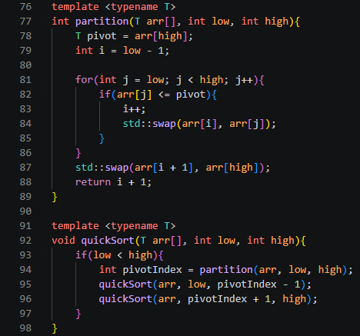  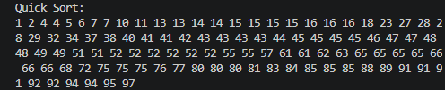
Observations | quickSort picks the last element as the pivot in partition, moves every smaller value to its left and every larger value to its right, then recurses on those two sides, so the array gets sorted without needing the extra memory that mergeSort allocates for its temporary arrays.
Table 8-4. Quick Sort Algorithm

2. ANSWERS TO SUPPLEMENTAL ACTIVITY
Problem 1:
Can we sort the left sub list and right sub list from the partition method in quick sort using other
sorting algorithms? Demonstrate an example

Yes. Once partition finishes, everything left of pivotIndex is guaranteed smaller than the pivot and everything right is guaranteed larger, so the two sides are just independent arrays at that point. Any correct sorting algorithm can finish sorting them instead of recursing with quicksort. Example, using insertionSort on both sides:

Main.cpp:
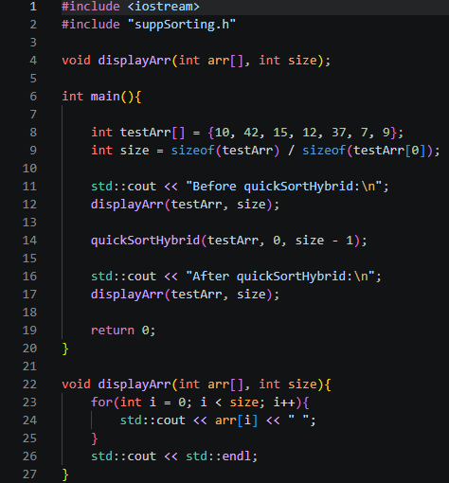
Sorting.h:
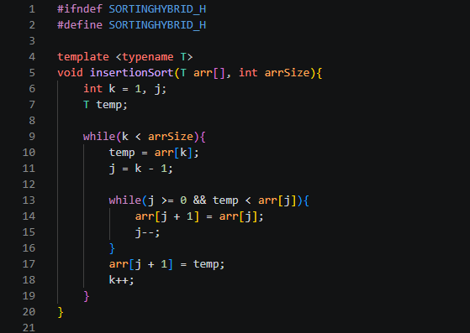
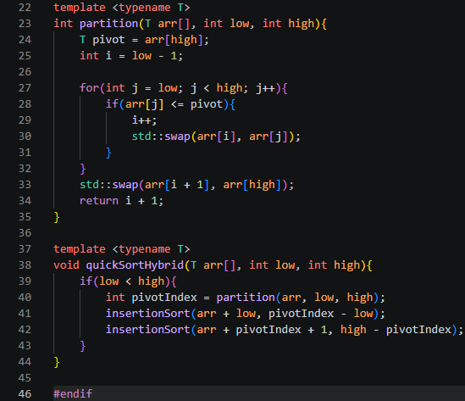
Output:
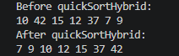

This still produces a fully sorted array since partition already placed the pivot correctly and separated smaller/larger values before insertionSort ever runs.

Problem 2
Suppose we have an array which consists of {4, 34, 29, 48, 53, 87, 12, 30, 44, 25, 93, 67, 43, 19, 74}. What sorting algorithm will give you the fastest time performance? Why can merge sort and quick sort have O(N·log N) for their time complexity?

For only 15 elements, a simple O(n^2) algorithm like insertion sort or shell sort will likely run fastest in practice, since there aren't enough elements for the O(n^2) comparisons to add up, and these algorithms skip the recursion overhead and (for merge sort) extra array allocation that merge sort and quick sort carry.
Merge sort and quick sort get O(N log N) because both use divide-and-conquer: they repeatedly split the array in half, which takes log2 N levels, and each level does O(N) total work overall (merging the halves in merge sort, partitioning around the pivot in quick sort). Multiplying the O(N) work per level by log N levels gives O(N log N) total.

Conclusion
In this activity, I learned how shell sort, merge sort, and quick sort each speed up sorting compared to the basic algorithms by using gaps, divide-and-conquer, and pivot partitioning instead of simple element-by-element comparisons. Working through the procedure showed me that all three algorithms sorted the same 100-element array correctly, but quick sort and merge sort clearly relied more on recursion while shell sort stayed closer to an optimized insertion sort. The supplementary activity helped me realize that quicksort's partition step is genuinely reusable since I could sort the resulting sub-lists with insertion sort instead of recursive quicksort and still get a correct result, which also made the O(N log N) complexity of merge sort and quick sort click for me since both split the work into log N levels of O(N) work each. Overall I think I did well since I got all three sorts and the hybrid version working correctly with proper output. My main area for improvement is spending more time comparing actual runtime performance between the algorithms instead of just confirming that each one produces a sorted array.

3. ARTIFICIAL INTELLIGENCE (AI) USE DISCLOSURE STATEMENT
I hereby declare that artificial intelligence (AI) tools were used, if applicable, in the preparation of this academic work. The following indicates the nature and extent of AI assistance:

Tools Used: | ChatGPT & Grammarly
Examples: ChatGPT, Microsoft Copilot, Grammarly, QuillBot, etc.

Purpose of Use: | Grammar correction & code assistance
Examples: grammar correction, idea generation, formatting, summarization, code assistance, explanation of concepts, etc.

Extent of Use: | Helped me to debug my code
Explain how AI was used and confirm that it did not replace original thinking, analysis, authorship, or completion of the required work.

By submitting this activity, I affirm that my use of AI complies with T.I.P.’s AI usage policy and does not exceed the permitted limits for similarity, automated content generation, or academic assistance.

I understand that any false, incomplete, or misleading disclosure may be subject to investigation in accordance with due process and may result in sanctions for violation of existing T.I.P. policies.

Lab activities, templates, and related instructional materials shall not be reuploaded, reproduced, distributed, or shared with external organizations or third parties without the prior express written permission of the Technological Institute of the Philippines.

